
User Manual for Flash Version
14th October 2011

Contents
File structure on the Server 3
Contents and function of each folder/file 4
URL Parameters 5
Event Timing 6
Merging the Logs 7
Playing the Game 8

File structure on the Server

The file structure on the web server should be as follows in order for the game to work.

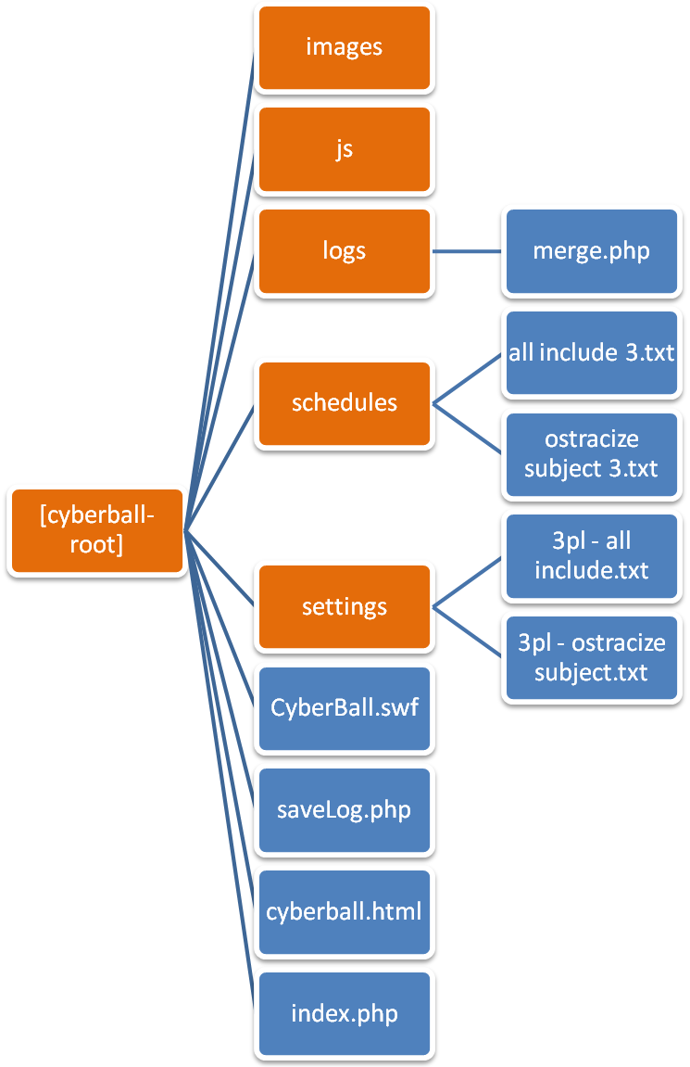
The blue boxes represent files. The others represent directories/folders.

Contents and function of each folder/file

The contents and function of each folder is as below:
- Images – Contains images used on the title/intro screen.
- Js – Contains javascript files needed to embed the swf in html
- Logs – All the user logs are uploaded to this folder after the game is over. It also contains the following files other than csv logs. The PHP server process needs to have write permissions to this folder in order to be able to save the logs.
  - Merge.php – This file is used to merge all the logs currently present into a single .csv file.
- Schedules – Contains the Schedule files which will be used by the computer players for each setting of the game. The files are:
  - all include 3.txt
  - ostracize subject 3.txt
- Settings – Contains the Settings files that are to be used for each type of game. The game uses only the values of Total Throws and Schedule from these files. The game ends after the ball has been thrown for the number of times specified by Total Throws. The value of Schedule if used to fetch the Schedule file from the server. The settings files are:
  - 3pl - all include.txt
  - 3pl - ostracize subject.txt
- CyberBall.swf – The main game file.
- saveLog.php – This file is used to send user log data from flash to the server. It saves the log data to the logs directory in the format <userid_timestamp>.csv
- index.php – Used as the title/intro screen
- cyberball.html – Used to embed and play the game swf file. Title screen links to this file.

URL Parameters

The various parameters used in the URL are as follows:
No. | Parameter | Valid Value(s) | Invalid Values | Description
1 | userid | Any string of characters. |  | This value will be used to create the log csv file.
2 | settings | - 3plos  - 3pall | Any other | The game will fetch the respective settings and schedule from the server
3 | pics | true | Any other | If set to true, the game will display images besides the player cartoons.
4 | pic1 | Any valid image URL |  | The URL of the image to be displayed besides player one’s cartoon
5 | pic3 | Any valid image URL |  | The URL of the image to be displayed besides player three’s cartoon
6 | chat | true | Any other | If set to true, the game will display a chat box in which the user can enter messages.
7 | p1name | Any string of characters |  | This value will be shown as the name of player one
8 | p3name | Any string of characters |  | This value will be shown as the name of player three

Event Timing

Various timed events in the game are:
- The “Connecting to other Players” screen is displayed for a random number of seconds between 5 and 7.
- Player One sends the chat message “Hey!” after a random number of seconds between 3 and 5 after the game starts.
- The computer players throw the ball after a random number of seconds between 0 and 4 once they have the ball in hand.
- The game timed to end once 2 minutes have passed since the start.

Merging the Logs

To merge the logs, make sure that the file named merge.php is in the logs folder as stated previously and then enter its URL in the browser’s address bar. For example: http://thesite.com/cyberball/logs/merge.php
All the log files will be merged and a single file will be provided as a download.

Playing the Game

Open the URL of the game(such as http://somesite.com/cyberball) in the browser.
You will be presented with the following screen.
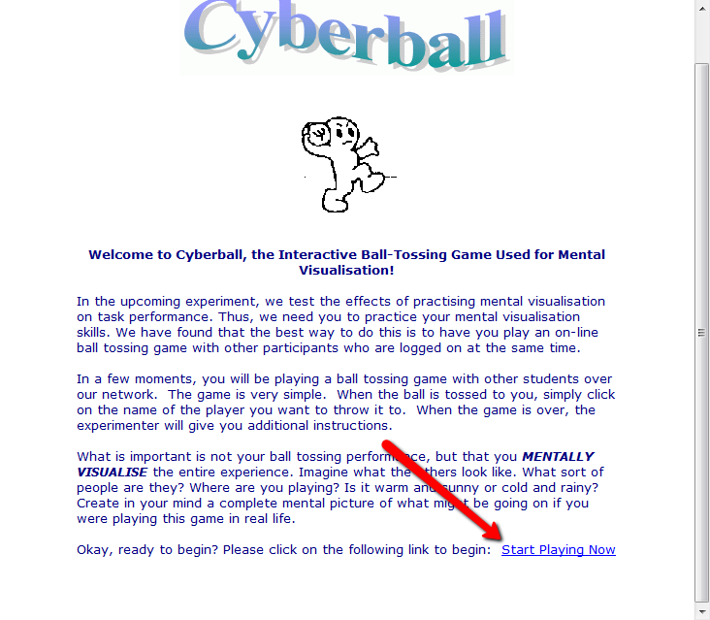

Click on the “Start Playing Now” link. The game will now start and will connect to other online players playing cyberball. Once connected, you will be taken to the following screen.
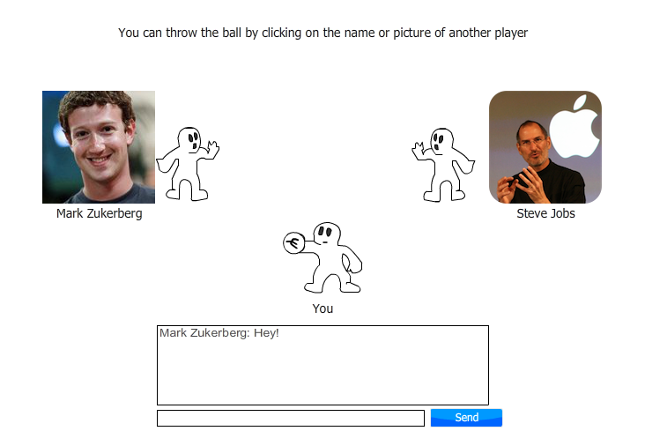

The actual screen you see may vary depending on the server settings and the game version.
You can send messages to other players using the chat box.
The ball can be thrown to any other player by clicking on their image or on their cartoon.

